Mail Delivery Robot Operational Domain | 8 October 2020

Author: Thomas Clement

**Mail Room:**

The mail room has one entrance. It is a wheelchair accessible door, so the width of this door will not be a limiting factor in the size of the delivery robot. The door is not powered, so either the robot must be made capable of opening the door by itself, or there must be human intervention.

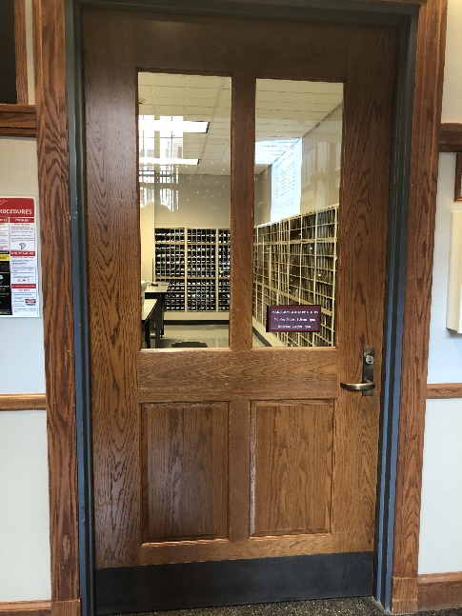

Figure 1: The door to the mailroom.

**Breen Student Union:**

The Breen Student Union, which contains the mail room, has four entrances. Each has a foyer which the robot must travel through. The two entrances on the Southern corners of the building do not have powered doors. These doors, which are quite hefty, will make it difficult for the robot to exit through them. The two entrances on the Western corners of the building lead to stairs, which would be difficult for the robot to drive up or down. The North-Eastern entrance is the only door that is powered and does not have stairs leading down from it. This is also the entrance furthest away from the destination Hoyt Hall.

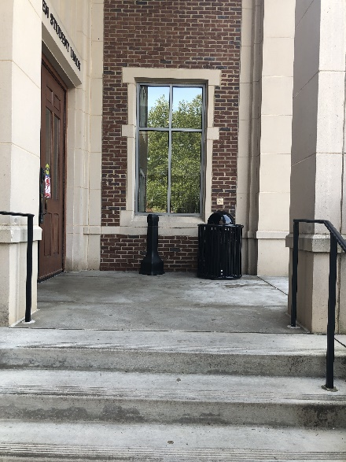

Figure 2: An outside view of the North-Western entrance.

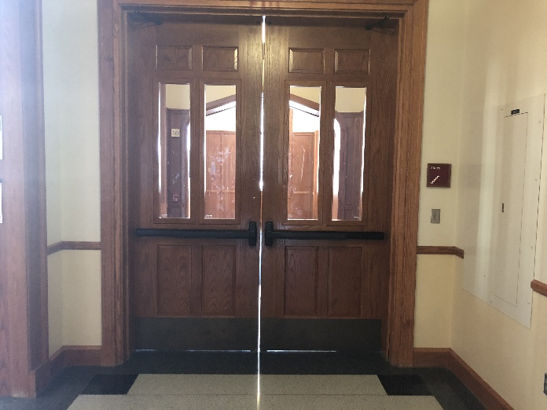

Figure 3: An inside view of the South-Eastern entrance.

**Outdoors**

The pathways between the Student Union and Hoyt Hall are marked on the image taken from Google Earth below. The sidewalks are well maintained. In the winter, they can be icy, but the college groundskeepers typically keep them clear of snow and ice. The temperature outside typically goes as low as 17 $℉$ and can be in the range of 80-90 $℉$ in the Summer $.^{1}$

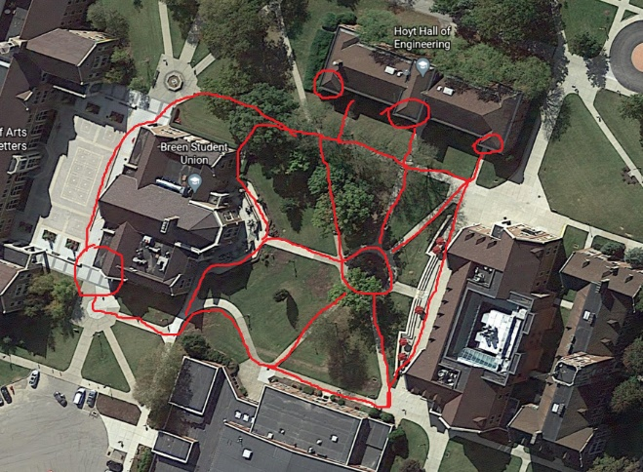

Figure 3: An aerial view of the sidewalks between The Breen Student Union and Hoyt Hall $.^{2}$

**Hoyt Hall:**

Hoyt hall has three entrances on the North Side of the building. One of these entrances has a foyer. None of the doors is powered. The doors without a foyer are single doors that measure 41.5” wide. The foyer entrance is a set of double doors that are 71” wide. The entrance that the robot uses must be chosen based on the desired size of the robot and the difficulty of entering the building through a foyer. If the robot is so large that it needs to enter through the double doors, it may be too cumbersome to be able to navigate through a foyer.

**Machine Shop:**

The Machine shop houses Mr. Paich’s office. It is in the center of the building on the first floor. The door to the shop is only 33” wide, so it will be a limiting factor in the size of the robot unless the robot delivers packages outside the door to the machine shop.

**References:**

1: <https://www.msn.com/en-us/weather/today/Grove-City,PA,United-States/we-city?iso=US&el=GfrqM%2BwnFGu8NxLuKtu%2F7A%3D%3D> accessed 10/7/2020

2: <https://earth.google.com/web/search/200+Campus+Dr,+Grove+City,+PA/@41.15504507,-80.078141,400.9272504a,340.94584733d,35y,190.99073532h,0t,0r/data=CogBGl4SWAolMHg4ODMzNzU0MGUwNGRlNWU5OjB4YjU0MzEzMzg0ODYxYmYzORmReeQPBpREQCFJ8lzfBwVUwCodMjAwIENhbXB1cyBEciwgR3JvdmUgQ2l0eSwgUEEYASABIiYKJAkT6wjkCYVDQBFXw0Se04RDQBnfxE39lSBTwCGa-5WpvCBTwA> accessed 10/7/2020